谭树杰 11849060

# Lab7 Report

1. **There are two noisy images lenaWithNoise.pgm and** **cameraWithNoise.pgm. The task is to get the noise patterns and to design filters to remove or reduce the noise to get uncorrupted or better quality lena and camera images.**
2. lenaWithNoise.pgm and its magnitude image, magnitude image after bandreject filtering and processed image using bandreject filter are shown below

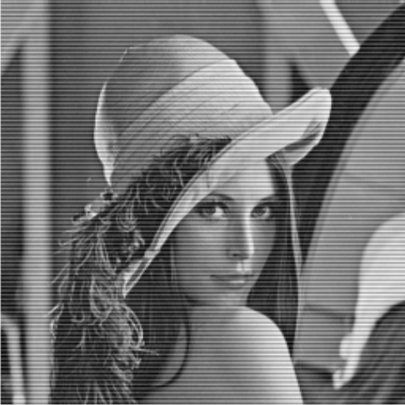 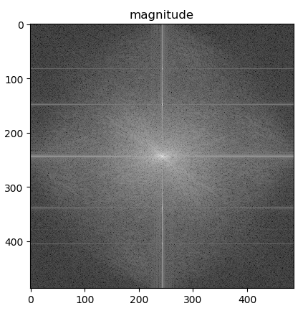

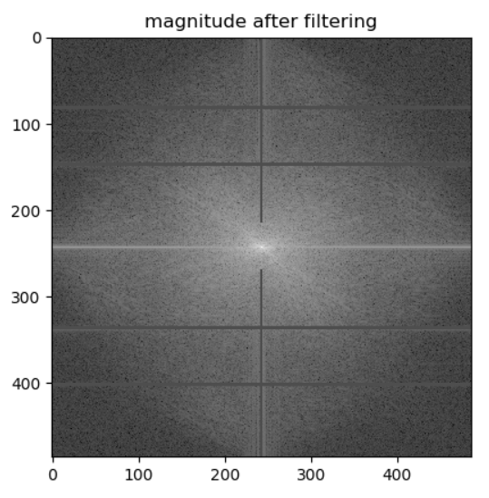 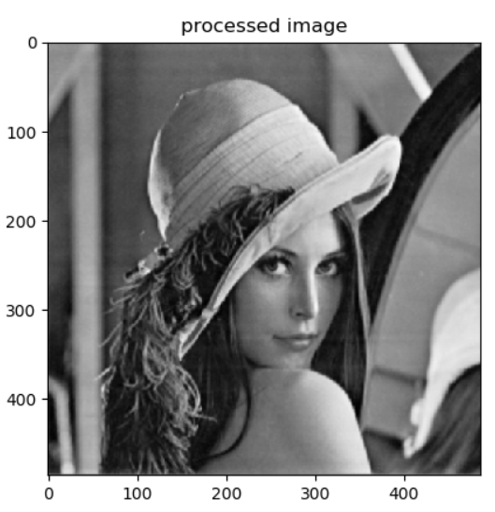

Magnitude after bandpass filtering and processed image are shown below respectively.

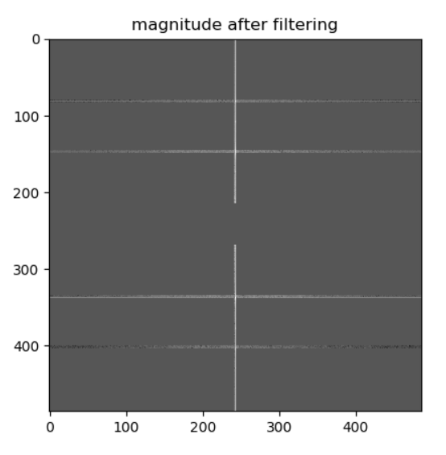 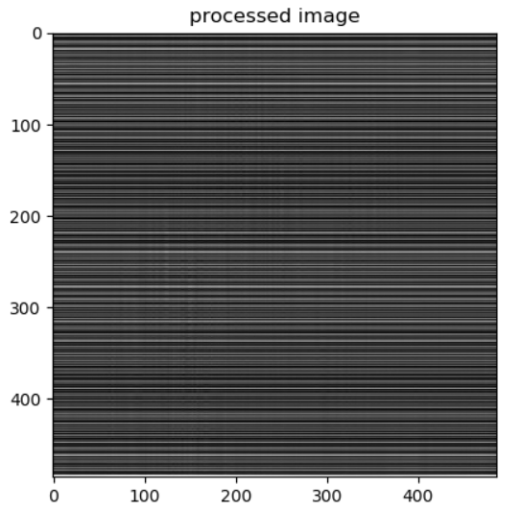

**Analysis:**

We can see four additional horizontal lines and an abnormal vertical line in the magnitude image, which are the magnitude of the noise image. We first calculate the location and then design a bandreject filter to filter the noise frequencies. As we can see, the image improved significantly.

We can get noise pattern by using a bandpass filter to the noise image. As we can see, the noises are mainly periodic noise.

**The implementation code is shown below:**





1. cameraWithNoise.pgm and filtered image using mean filter 2, 3 and 4 times are shown below. The filter size is 3 * 3.

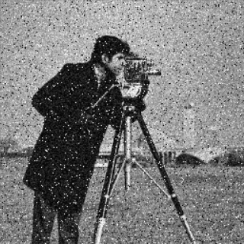 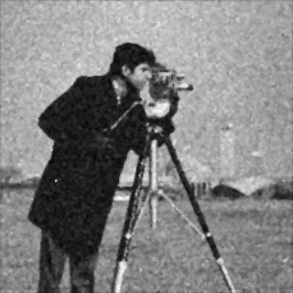

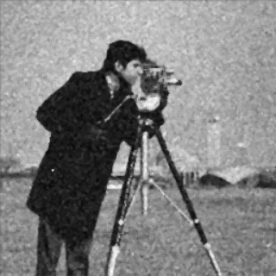

**Analysis:**

As we can see, the noise pattern is salt and pepper noise. Therefore, we design a mean filter with size 3 * 3 to reduce the noise. After filtering, the image improved a lot, although with the price of blurring. We repeatedly using the same filter and the image becomes more and more smoothing, hence we should choose the appropriate times of repeated filtering.

**The implementation code is shown below:**



**2. Use arithmetic mean filter, geometric mean filter, median filter, Alpha-trimmed mean filter, and adaptive median filter respectively to reduce the lenaD1.pgm, lenaD2.pgm, lenaD3.pgm. Analyze the results to see which filter is effective to which image.**

1. lenaD1 and result images by processing it with arithmetic mean filter, geometric mean filter, median filter, Alpha-trimmed mean filter, and adaptive median filter respectively are shown below (3 * 3 indicates the filter size, d is pixels trimmed and 3,11 in adaptive median filter represents the minimum, maximum filter size. The parameter representation in the following images are similar)1

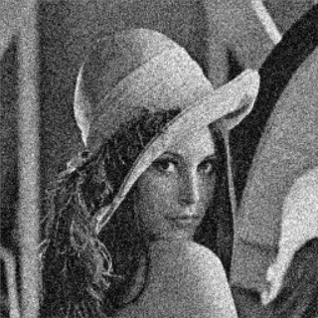 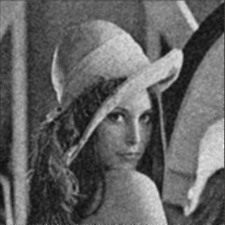 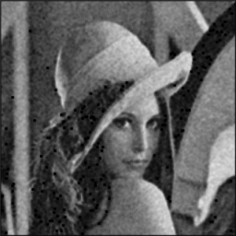

LenaD1.pgm (3*3) arithmetic mean (3*3) geometric mean(3*3)

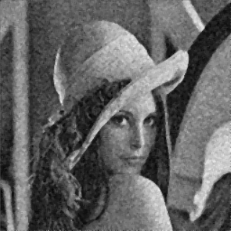 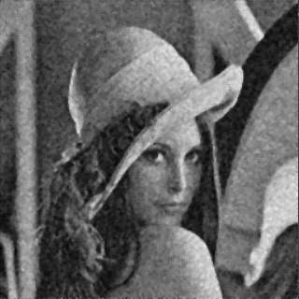 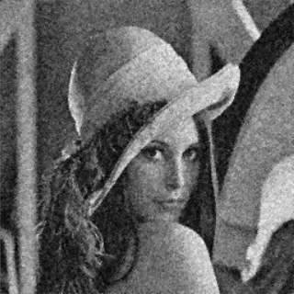

median filter (3*3) Alpha-trimmed mean(3*3,d=2) adaptive median filter(3*3,3,11)

 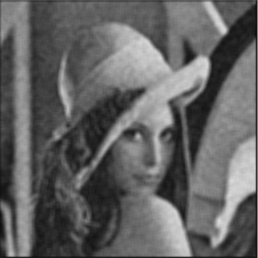 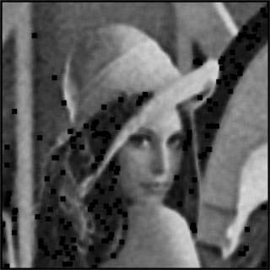

LenaD1.pgm (5*5) arithmetic mean (5*5) geometric mean(5*5)

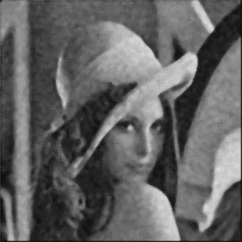 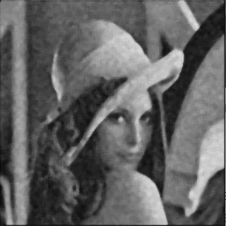 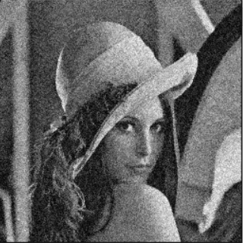

median filter (5*5) Alpha-trimmed mean(5*5,d=2) adaptive median filter(5*5,5,7)

**Analysis:**

Obviously, geometric median performs worst for that it introduces many black blocks in both filter size of 3 * 3 and 5 * 5.

As we can see, when the filter size is 3 * 3, there are still strong noise signal in the processed images. The adaptive median filter seems more sharper than others. As we increase filter size to 5, the noise is smoothed more, but the image is blurred more at the same time. Arithmetic mean filter, median filter, Alpha-trimmed mean filter are suitable for this kind of noise.

1. lenaD2 and result images by processing it with arithmetic mean filter, geometric mean filter, median filter, Alpha-trimmed mean filter, and adaptive median filter respectively are shown below:

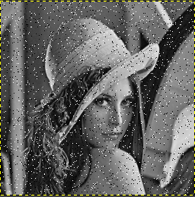 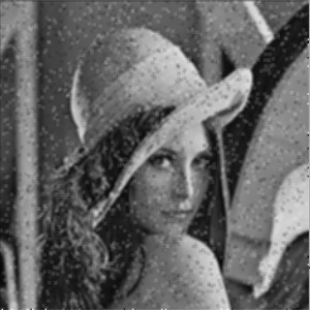 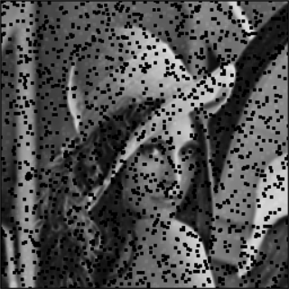

LenaD2.pgm (3*3) arithmetic mean (3*3) geometric mean(3*3)

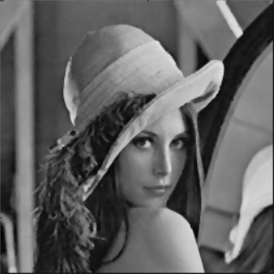 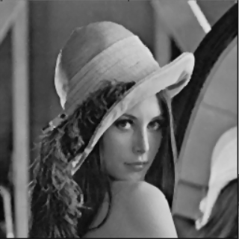 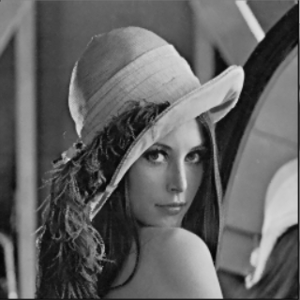

median filter (3*3) Alpha-trimmed mean(3*3,d=2) adaptive median filter(3*3,3,11)

 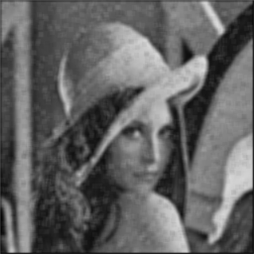 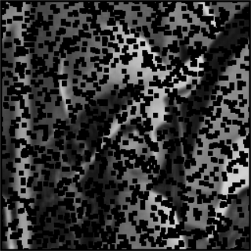

LenaD2.pgm (5*5) arithmetic mean (5*5) geometric mean(5*5)

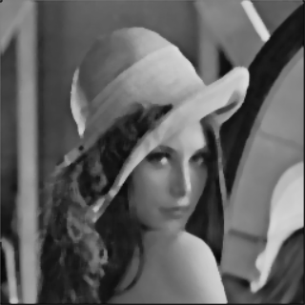 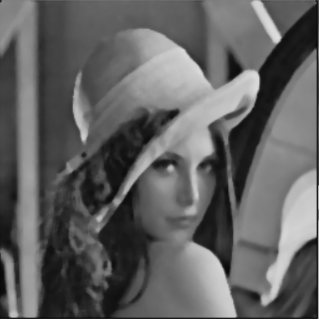 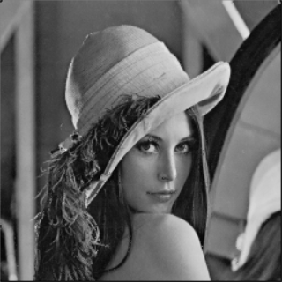

median filter (5*5) Alpha-trimmed mean(5*5, d=4) adaptive median filter(5*5,3,7)

**Analysis:**

Again, geometric median performs worst for that it introduces many black blocks in both filter size of 3 * 3 and 5 * 5. It’s hard to recognize original image when the filter size is 5 * 5.

Then the arithmetic mean filter blurred too details compared with others. The median filter and Alpha-trimmed mean filter shows good performance, but the adaptive median filter is the best choice to remove noise in lenaD2.pgm

1. lenaD3 and result images by processing it with arithmetic mean filter, geometric mean filter, median filter, Alpha-trimmed mean filter, and adaptive median filter respectively are shown below:

图片包含 雨伞, 掌握, 雨, 户外

自动生成的说明 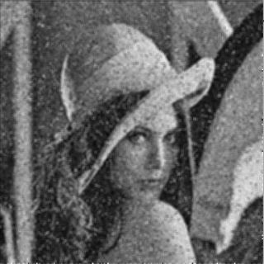 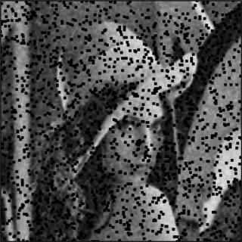

LenaD3.pgm (3*3) arithmetic mean (3*3) geometric mean(3*3)

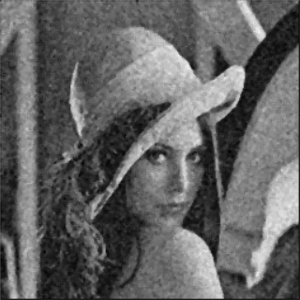 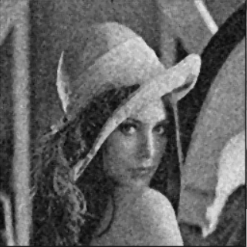 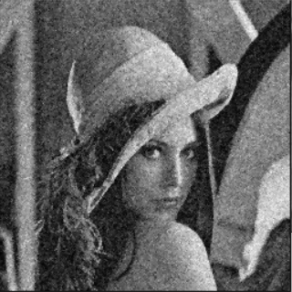

median filter (3*3) Alpha-trimmed mean(3*3,d=2) adaptive median filter(3*3,3,11)

图片包含 雨伞, 掌握, 雨, 户外

自动生成的说明 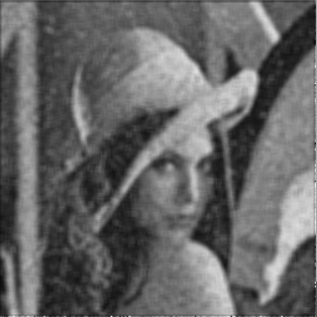 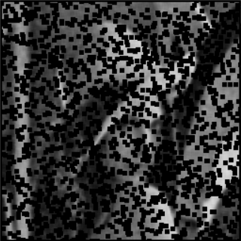

LenaD3.pgm (3*3) arithmetic mean (3*3) geometric mean(3*3)

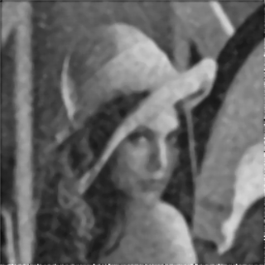 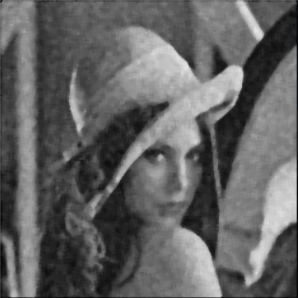 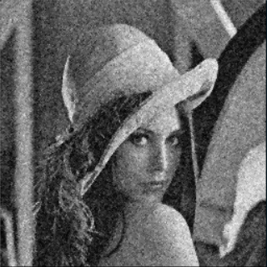

median filter (3*3) Alpha-trimmed mean(3*3, d=2) adaptive median filter(3*3,3,11)

**Analysis:**

Again, geometric median performs worst for that it introduces many black blocks in both filter size of 3 * 3 and 5 * 5. It’s hard to recognize original image when the filter size is 5 * 5.

Then the arithmetic mean filter can't remove enough noise compared with others. The median filter and Alpha-trimmed mean filter shows better performance, but they would blur more details than adaptive median filter. Therefore, adaptive median filter is the best choice to remove noise once again.

**The implementation code is shown below:**





